**DAILY ONLINE ACTIVITIES SUMMARY**

|  |  |  |  |  |  |  |
| --- | --- | --- | --- | --- | --- | --- |
| **Date:** | | **10/06/2020** | | | | |
| **Name of the Faculty** | | **Ankitha Shetty** | | | | |
| **No. of Students Allotted for monitoring** | | | | **16** | | |
| **Progress** | | | | **Good** | | |
| **Whether collected report from all the allotted students** | | | | **12 students are updating daily**  **2 students are involved in online activity.**  **2 students are not uploading anything.** | | |
| **Online Test Summary** | | | | | | |
| **Subject** |  | | | | | |
| **Semester** |  | | | **Duration** |  | |
| **No. of students Taken** | | |  | **Passing %** |  | |
| **Certification Course Summary** | | | | | | |
| **Course** | | 1. Applied machine learning using python 2. Workshop on **Technical Document Preparation using Latex.** 3. FDP on PERL scripting | | | | |
| **Certificate Provider** | | 1. **NMAMIT Nitte** 2. Dr. S. & S. S. Ghandhy Government Engineering College, Surat. 3. Lords institute of engineering and technology, in association with IIT Bombay | | **Duration** | | **2 hours** |
| **Coding Challenges** | | | | | | |
| Problem Statement: Python program to implement perfect sum problem | | | | | | |
| **Status: 35 students** | | | | | | |
| **Uploaded the report in Github** | | | | **Yes** | | |
| **If yes Repository name** | | | | <https://github.com/ankishetty91/ankitha-daily-report> | | |
| **Uploaded the report in slack** | | | | **Yes** | | |

**Certification Course Summary**

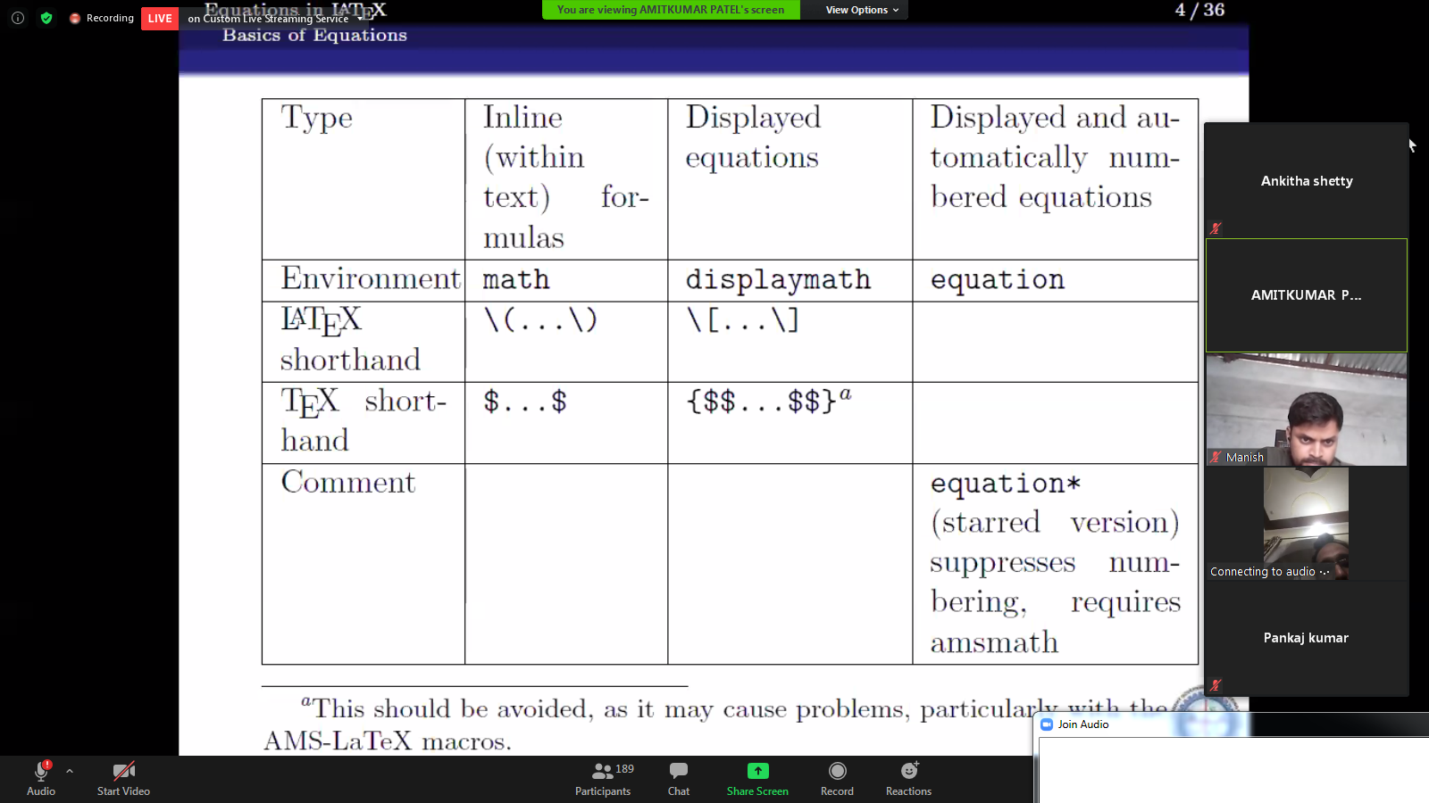

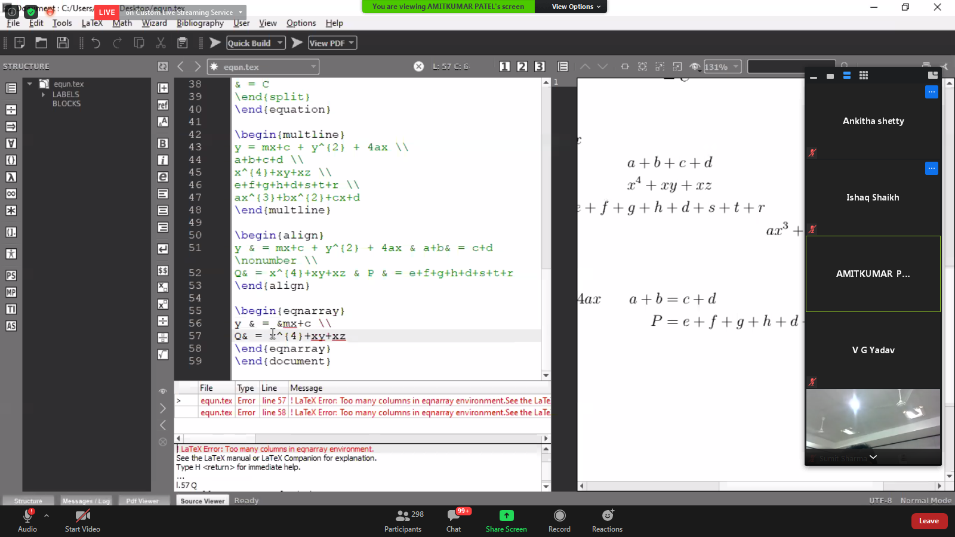

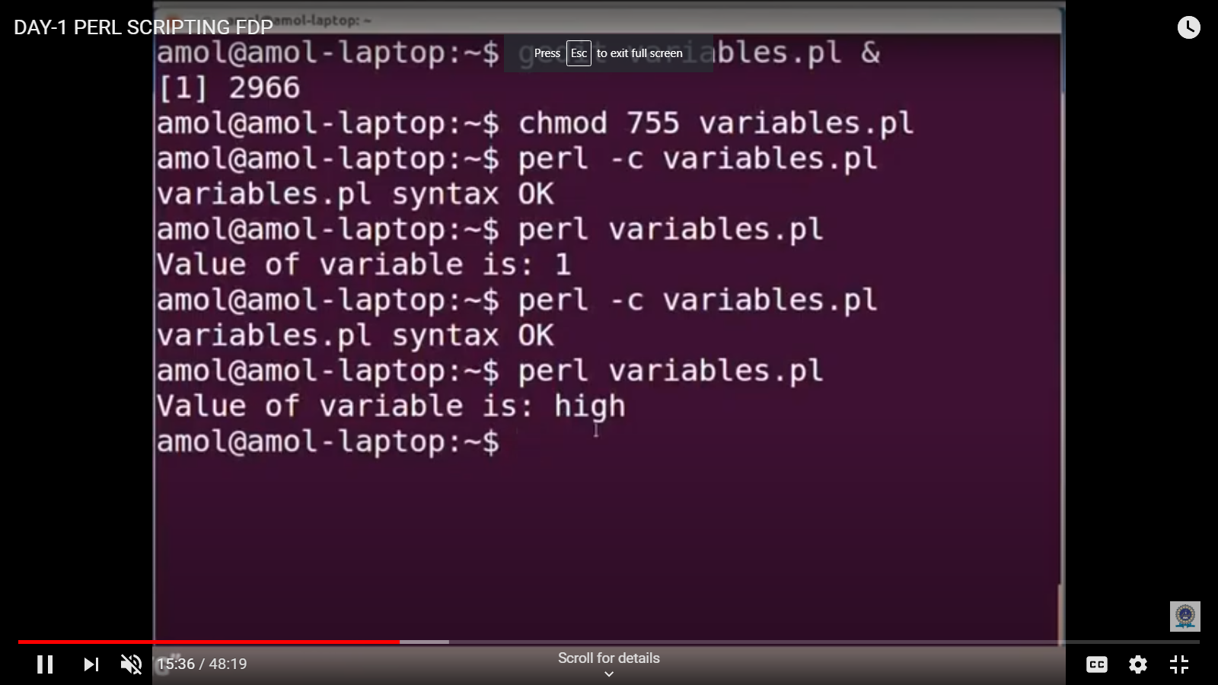

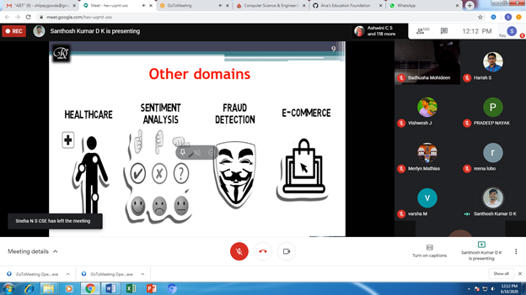

**Students Report:**



